|  |
| --- |
|  |



**25 January 2013** **The Weekly Bulletin of Rotary Club of Kathmandu Mid-Town** **Bc-25.1/012-13**

**District : 3292 Web: www.rotarymidtown.org.np Club Id : 26776**

**JANUARY IS ROTARY AWARENESS MONTH**

Awareness is an important part of the Rotary work that can be divided into two parts.

It is imperative that members are well aware of Rotary’s goals – that Rotary is an organization that works for peace and better understanding between people.

The other part of Rotary awareness is the sharing of information outside of our organization.

Friday, 18 January:

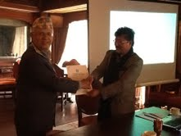

Guest Speaker Prachand M Shrestha provided a quick overview of

tourism business in the world as well as in Nepal. Role of government,

efforts of private sector, challenges, constraints, opportunities,

nature's endowment, a variety of products,

failure of government, tourism infrastructure,

In the picture, President Devendra handing over letter of appreciation to Guest Speaker Rtn Prachand

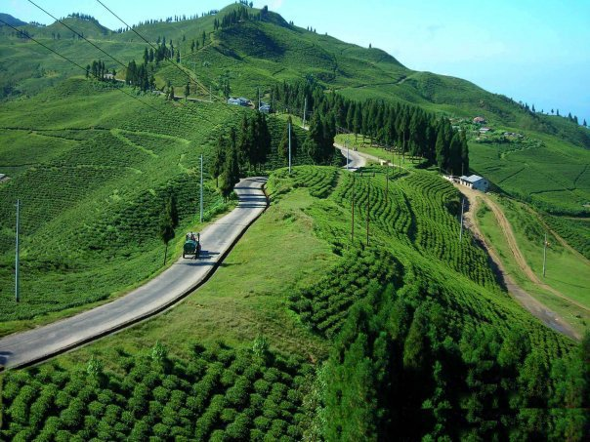

*Tourism product ?*

# Weekly Meetings and Programs :

|  |  |  |
| --- | --- | --- |
| Date | Program/Speaker | Program/Topics of Presentation |
| 25 Jan 2013 | Radha Poudel, President, Action Works Nepal | Women right ? |
|  |  |  |

Friday, 18 January *Cont'd*

*President Elect Saroj Shrestha announces Club's Board for Rotary Year 2013-14.*

***Congratulations to all !***

1. President Saroj Shrestha

2. IPP Devendra N Gongal

3. President Elect : Dr. Kul Chandra Gautam

4. Vice President: Dr. Alexander Spachis

5. Secretary: Paras SJB Rana

6. Joint Secretary: Promod Poudel

7. Treasure: Jo Logghe

8. Club Administration Chair: Govinda Chipalu

9. Membership Chair: Dr. Rabindra Shrestha,

10. Public Relation Chair: Ranjit Acharya

11. Service Project Chair: Rabi Karmacharya

12. The Rotary Foundation Chair: Komal Chitracar

13. New Generation Chair: Dr. Chandra Lekha Tuladhar

14. Sergeant-At-Arms: Shyam Thapalia

*courtesy:* *PE Saroj Shrestha*

*President Devendra providing PHF pin to Rtn Bodde and certificate to Rtn Paras*.

Friday, 25 January:

Ms. Radha Poudel will be our Guest Speaker for the day. She is the Founder as well as President of Action Works Nepal. The organization focuses on human right of women, dalit, disabled, conflict-affected, and other forms of marginalization through policy advocacy, capacity building, media mobilization and "Let's Live Together" campaign primarily in Karnali zone, Nepal.

**From the Club Secretary's Desk:**

pproval !

Buddha Laishram, Club Secretary

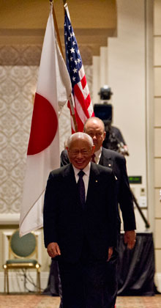

… the day I joined the Rotary Club of Yashio was a day when I took my first step down a different path in life – a path of greater connection, greater satisfaction, and a deeper sense

of fulfillment and peace.

**RI President Sakuji Tanaka**

**Committee Chairpersons' Column:**

**Past Presidents' Column:**

**?????**

**Club Members' Corner:**

Notice: Please note change of email address, mobile number etc

Members' Name Old one Now changed to

*PP Dr Lekha Tuladhar mobile : 9851026797 9801026797*

*email : racs@wlink.com.np drlekhatuladhar@gmail.com*

*PP Anand Tuladhar mobile : 9851020842 9801020842*

*PP RR Shrestha email : rryes@wlink.com.np rryesrr@gmail.com*

On lighter side :

Click here ⇩

A thought for the day:

**One of the basic differences between God and human is :**

**God gives, gives and forgives.**

**But human gets, gets, gets and forgets.**

**Be thankful in life !**

Great quotes:

***Never make a bit of gap between the dear ones,***

***because you will never bear the pain when the gap is filled by someone else !***

Puzzle:

What comes next in the series: 3, 7, 16, 35, …. ?

Last week puzzle solution: If 00 = 8, 01 = 9, 11 = 7, 111 = 4

NB: Send any informations/photos that may be of interest to the Club or Rotarians in general to

BC Editor: RR Shrestha email: rryesrr@gmail.com

## 25 Jan 2013 The Weekly Bulletin of Rotary Club of Kathmandu Mid-Town bc-25.1/012-13

From: [Adam.Arents@rotary.org](mailto:Adam.Arents@rotary.org)  
To: [deveng.gongal@gmail.com](mailto:deveng.gongal@gmail.com)  
CC: [supriya_aries_march@hotmail.com](mailto:supriya_aries_march@hotmail.com); [sibabr@gmail.com](mailto:sibabr@gmail.com); [yogendra_pradhan@hotmail.com](mailto:yogendra_pradhan@hotmail.com); [dibyajoshi@gmail.com](mailto:dibyajoshi@gmail.com)  
Date: Wed, 9 Jan 2013 16:43:20 -0600  
Subject: Congratulations to the Interact Club of Kathmandu Mid Town

Dear Club President Devendra Nath Gongal,

As you may be aware, one of the Interact clubs you sponsor, the Interact Club of Kathmandu Mid Town, submitted an entry to this year’s Interact video contest. I am happy to report that their entry, “[Today’s Tomorrow](http://youtu.be/jh20u33uB9k),” has been selected as one of three finalists in this year’s contest!

Our panel of judges chose one grand prize winner and three finalists from a competitive field of entries submitted by Interact clubs in 11 countries on five continents. The winning videos will be featured on Rotary.org and social media, and the winning clubs will receive a signed letter from President Tanaka and an engraved plaque. We also plan to host a Facebook chat with the winning clubs on Tuesday, 22 January from 9:30-10:00AM PST.

I hope you will join us in spreading the word about this accomplishment once the announcement is made Thursday in an RI news story, the New Generations newsletter, and on the [Interact Facebook page](https://www.facebook.com/interactofficial). Last year’s winners received positive coverage in local media about their video’s success in this international competition.

Thank you for all you do to support the service of these Interact students. My congratulations to the Interact club, your Rotary club, and your district for on this achievement.

Kind regards,

Adam

**Adam Arents**   
[adam.arents@rotary.org](mailto:adam.arents@rotary.org)  
Promotions and Program Coordinator, New Generations  
**ROTARY INTERNATIONAL**[www.rotary.org](http://www.rotary.org/)

**R**I President-elect Ron Burton will ask Rotarians to *Engage Rotary, Change Lives*in 2013-14.He unveiled the RI theme during the opening plenary session of the 2013 International Assembly in San Diego, California, USA, the annual training event for incoming district governors.“If we really want to take Rotary service forward, then we must make sure that every single Rotarian has the same feeling about Rotary that each one of us here has today,” Burton said. “We need to make sure that every Rotarian has a meaningful role to play, that they’re all making a contribution, and that their contribution is valued.”Burton said the July launch of [The Rotary Foundation’s new grant model](http://www.rotary.org/en/grants), Future Vision, makes it an exciting time to be a Rotarian. He said the new grant model, which has been used by about 100 pilot districts since 2010, represents a new era for the Foundation, and will help Rotarians get excited about Rotary’s ability to change lives.“It takes everything that is wonderful about Rotary and raises it to a new level — by encouraging bigger, more sustainable projects while providing increased flexibility for local projects, both of which address the needs of the community being served,” he said.Burton asked the incoming district governors to take the lead in helping their clubs through the transition, with the assistance of their district Rotary Foundation chairs, who also attended the assembly this year. The training sessions are focusing heavily on equipping these leaders to go back to their districts as experts on the new grant model.Before the assembly, Burton asked each of the incoming governors to make a donation in their name to The Rotary Foundation in order to demonstrate leadership by example. At the assembly, he announced that all 537 governors-elect had complied; along with donations from all RI Board members and Foundation Trustees, the contributions totaled US$675,412.“Now, I have to believe that some of this is money that The Rotary Foundation probably would not have received had I not asked. And I think that this is an important lesson” he said. “If you want somebody else to do something, you can just sit around and wait for them to get the idea, or you can ask.”Burton applied that lesson also to membership development, which he insisted is the responsibility of every Rotarian. He told the audience that although he had been an active member of the Key Club, a youth program of Kiwanis International, he went on to join Rotary simply because the Rotary Club of Norman, Oklahoma, invited him to.“You have to ask,” he said.But Burton emphasized that the job doesn’t end when a new member joins: “It’s not done until that new member is engaged in Rotary, inspired by Rotary, and uses the power of Rotary service to change lives.”

